www.thediversebookawards.co.uk
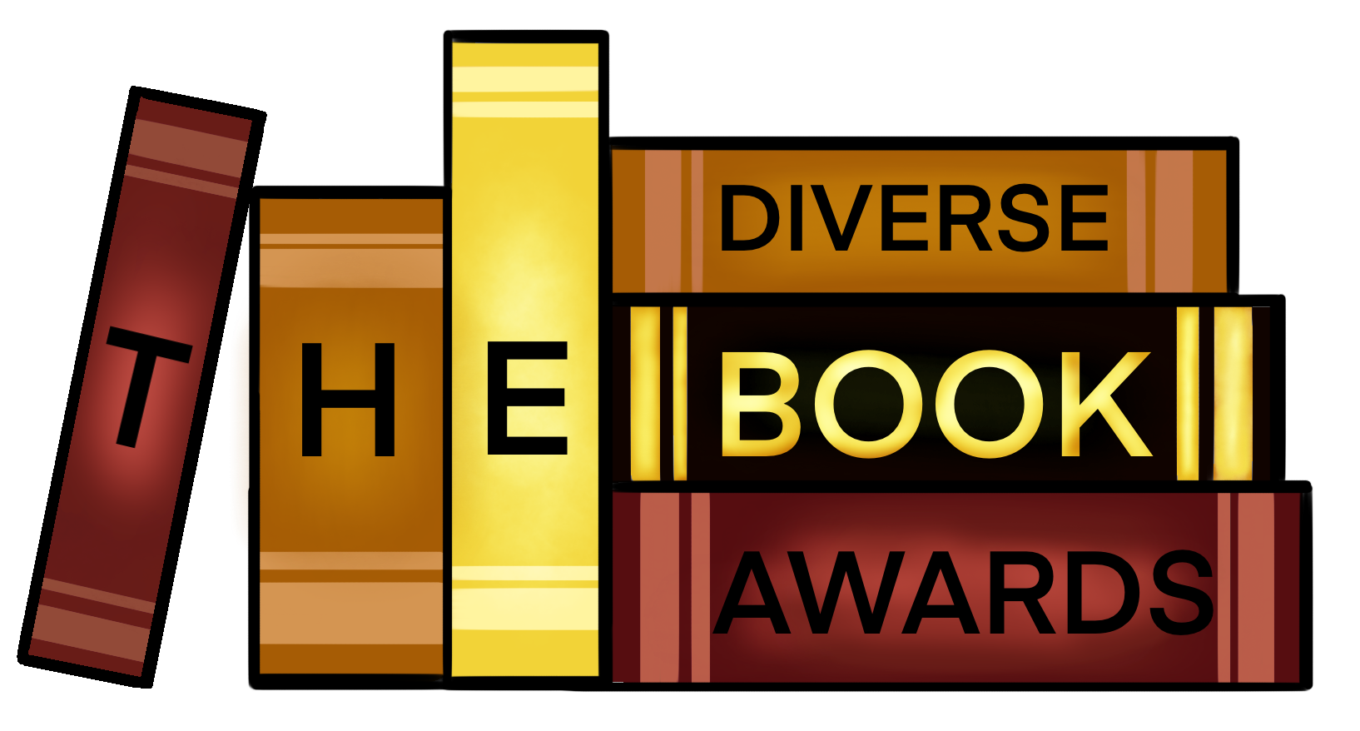
Blogger Form
Welcome to the 2022 Diverse Book Awards!

Please check you’re answering YES to the following questions before you complete the form:

- Are you a UK based blogger?
- Are you willing to take pictures of the longlist, shortlist and winning books?

We don’t care how many followers you have, we just want stunning pictures and an enthusiastic blogger!
- You will get all books on the longlist
- All the pictures will be credited to you.
- If the winners from 2021 can’t announce one of the winners then you will be asked to.

Name:

Age:

Where in the UK are you based?:

Instagram and Twitter handle:

Blog website:

In 100 words or less please tell us why you want to work with The Diverse Book Awards?

Please send this completed form to hello@thediversebookawards.co.uk along with your best three #Bookstagam pictures.

www.thediversebookawards.co.uk
@the_dbawards

